Tech Saksham

Case Study Report

Data Analysis with Power BI

“ Supply chain Analysis of Inventories”

“N.M.S. Sermathai Vasan college for women”

|  |  |
| --- | --- |
| NM ID | NAME |
| 5EA9107880DC912BE664164B550BFCD7 | V. Krishnaveni |

Trainer Name : R.Umamaheswari

Master Trainer :R. Umamaheswari

INTRODUCTION:

A supply chain is generally composed of many different organizations or departments that are responsible for all the activites thet are required to satisfy the customer demand in production or service systems. These activities include many different functions such as procurement of materials from suppliers, production, warehousing, distribution, marketing, financing, after sales service etc. Some of these activites are done within the same company while other might be done by other companies in the supply chain. Supply chain management (SCM) deals wit organizing and coordinating all these activities in order to satisfy the customer demand effectively and efficiently. Supply chai managers aim to desing systems and make decisions to obtain the highest profit for the whole system.

In today’s world, the increasing competition in global markets and advances in information technologies have forced the companies to coordinate their activities with the other companies that they work with the other companies that they work with, such as their supplier, distributors, retailers etc. Focusing only on the internal operations is not enough to compete in today’s world. The companies that can not coordinate their activities with the other supply chain members have difficulties in competing with their competitors. Relations of companies with each other in a supply chain have started to become much more impotarnt and attracted much more attention over the years. Competiton between the companies has extended to become competition between supply chains. A supply chain’s success depands on all the functions and entities in a supply chain need to work together and coordinate their activities in order to ensure success.

BASIC CONCEPTS IN SUPPLY CHAIN MANAGEMENT:

In a typical supply chain, different companies such as suppliers, manufactures, distributors and retailers work together in an integrated manner in order to satisfy the customer demand.

Supply chain management deals with the integration and coordination of all process in order to increase the efficiency and profitability of supply chain.

Supply chain management aims to produce and distribute the products to the right locations, at the right time, in the right quantities, in order to maximize systemwide profitability while satisfying customer service levels.

According to APICS(2020), the performance of supply chains is measured by the following five key performance areas:

1. **Reliability:**

Defined as the ability to perform tasks as expected. On-time delivery, providing the right quantity and the right quality are some of the typical metrices for reliabilitiy.

**b.Responsiveness**:

Defined as the speed at which tasks are performed. The tine needed to satisfy the customer needs or cycle-time metrics are examples of typical metrics for supply chain responsiveness.

**C. Agility:**

Defind as the ability to respond to external influences or changes in the market to gain or maintain competivtive advantage.Flexibility and adaptability are some of the typical metrics for agility.

**d.cost:**

Defind as the cost of operating the supply chain process, including labor costs, material cost, management and transportation costs among others. Cost of goods sold can be used as atypical metric for cost.

**e.Asset Management Efficiency**:

Defined as the ability to efficiently utilize assets. Capacity utilization or inventory days of supply are among the typical metrics for asset management efficiency.

Supply chain management deals with all the activities during the flow of products from the raw material state to delivery to end-users.

As stated above , sourcing, production and distribution are the basic processes in a typical supply chain and these process are explained in more detail below.

SOURCING (Procurement):

Sourcing refers to the process to obtain or buy goods or services required for production. In order to satisfy the customer expectations, companies need to procure the right products, at the right time, at the right location, at the right price, at the right quality and in the right quantity.

SUPPLY CHAIN STRUCTURE:

Extended supply chains include three other types of participants:

(i) the supplier’s supplier or the ultimate supplier at the beginning of an extended supply chain,

(ii) the customer’s customer or ultimate customer at the end of an extended supply chain,

(iii) service providers to other companies in the supply chain, which supply services in logistics, finance, marketing, information technology, etc.

Suppliers, producers, distributors, retailers and customers are the main components of a typical supply chain, in addition to various service providers that provide services to these components

SUPPLY CHAIN MANAGEMENT STRATEGIES:

Globalization of businesses have forced the companies to change their strategies in order to effiectively coordinate their operations. A key factor in this change is establishing closer relations with suppliers and customers. Companies and their suppliers compete as a supply chain with other supply chains to deliver better quality products in a faster manner. Customers expect high quality customized products, cheaper prices, faster and reliable deliveries, and companies need to satisfy these expectations in order to continue their existence. These expectations require closer relations and coordination with suppliers and other related

companies. In addition, increasing uncertainty in customer develop its own strategy depending on its customers’ expectations in order to become successful and improve its performance.Every supply chain needs to develop its own strategy depending on its customers’ expectations in order to become successful and improve its performance.

SERVICE USED:

* Data collection and storage service: Bank need to collect and stroe customer data in supply chain .This could be achieved through services like Azure Data Factory, Azure Event Hubs, or AWS Kinesis for supply chain collection, and Azure SQL Database or AWS RDS for data storage.

*Data Processing Services: Services like Azure Stream Analytics orAWS Kinesis Data Analytics can be used to process the supply chain.

*Machine Learning services:Azure Machine Learning or AWS Sagemaker can be used to build predictive models basedon historical data.

TOOLS AND SOFTWARE USED:

**TOOLS:**

* **PowerBI:** The main tool for this project is powerBI,which will beused to create interactive dashboards for supply chain data visualization.

**\* Power query:** This is a data connection technology that enables you to discover, connect, combine, and refine data across a wide variety of sources.

**SOTWARE REQUIREMENTS:**

**\* PowerBI Desktop:** This is aWindows application that you can to create reports and publish them to PowerBI.

* **PowerBI Service:** This is an online Saas (Software as a service) service that you us to publish reports, create new dashboards, and share insights.

**\* PowerBI Mobile:** This is a mobile application that you can use to access your reports and dashboards on the go.

Dashboard:

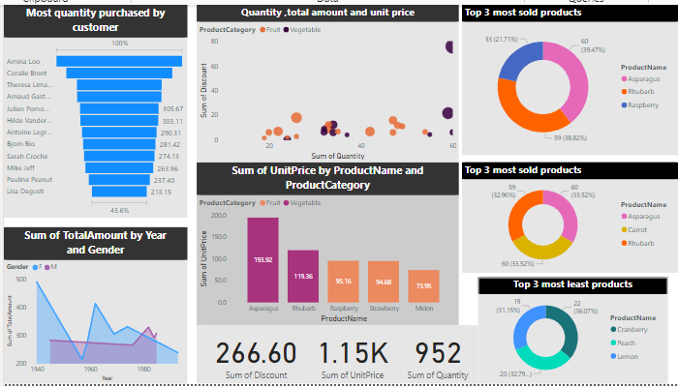

Link:

<https://github.com/dgkmv2023/suppy-chain-analysis-of-inventories>

<https://github.com/dgkmv2023/suppy-chain-analysis-of-inventories>